**Interpretation of**

**ANSI/AMCA Standard 204-2020**

***Balance Quality and Vibration Levels for Fans***

(Approved 1/20/2025)

**Request from:** Varun Prakash Puneria

Senior Tunnel Ventilation Engineer at Peter Kiewit Sons Inc.

4350 Still Creek Drive, Suite #210

Burnaby, BC, Canada V5C 0G5

**Reference:** This request for interpretation refers to the requirements presented in AMCA 204-20, *Balance Quality and Vibration Levels for Fans,* Page 12-13, Section 6, Table 6.1, relating to distinction between tunnel fans and tunnel jet fans.

**Background:** In Table 6.1 of AMCA 204-2020 version, under application category "Transit and Tunnel", it is unclear as to what is considered as "Tunnel Fans" and what is considered as "Tunnel Jet fans". The vibration limits being different for each kind, we have differences in interpretation between the stakeholders. We are procuring fans, termed as jet fans by the fan manufacturer and we would like to apply vibration limits of "tunnel jet fans" to them. Can the authorities please define tunnel fans, tunnel jet fans, as well as other fan types referred in the standard?

**Interpretation:** Our interpretation is as follows.

a) All jet fans are considered as tunnel jet fans in the context of this standard. b) Tunnel fans and jet fans are not considered as the exact same type of equipment per the standard. Please confirm if a) is correct? Please confirm if b) is correct?

**Question:** Please confirm that the vibration limits of BV-4 apply for jet fans irrespective of motor horsepower rating per AMCA 204-2020 standard. Please confirm that all jet fans are considered as tunnel jet fans per the standard. Please confirm that tunnel fans and jet fans are not considered as the exact same type of equipment per the standard.

**Answer:** Tunnel Jet Fans are considered a subset of jet fans according to AMCA 204-20. Accordingly, it has a more stringent vibration tolerance per AMCA 204-20 Table 6.1 below:

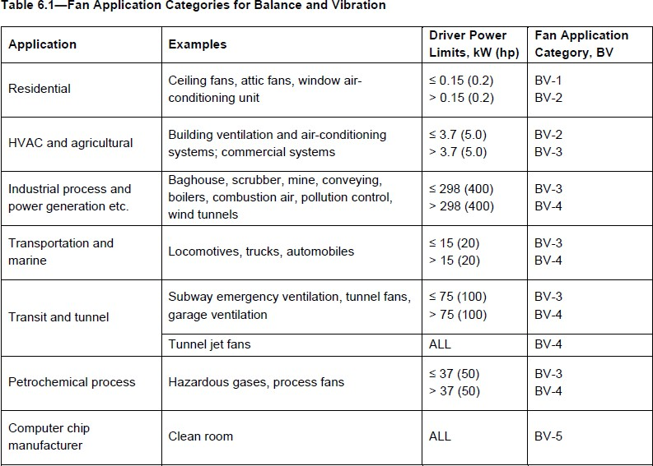

|  |
| --- |
| As stated above All TUNNEL jet fans are held to the higher BV-4 std. This is because of higher safety standards and safe evacuation requirements in case of a fire in tunnels. Fan application categories for jet fans in other applications would be subject to its application and driver power limit. *AMCA-99-16 defines a jet fan as: “A fan in a tunnel that induces airflow by entrainment of air with that streaming from the fan outlet.” ISO 13349 defines a jet fan as: “fan used for producing a jet of air in a space and unconnected to any ducting.” Per these definitions, a tunnel jet fan can be considered a jet fan applied to a specific application*. |